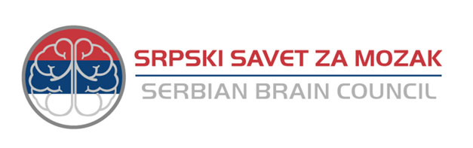

SERBIAN BRAIN COUNCIL RECOMMENDATIONS ON
HORIZON EUROPE
FRAMEWORK PROGRAMME

Commission’s proposals for the next Research and Innovation Framework Programme
COM (2018) 435 Final and COM (2018) 436 Final

August 2018

Serbian Brain Council (SrBC) is established in 2015 and is a member of European Brain Council with observer status. Its goal is to serve as an umbrella non-profit organization to work with Serbian associations and institutions as well as with patient organizations in the field of neurology and neurosciences.
Within the European Brain Council SrBC acts with the Belgium Brain Council, French Brain Council, and the Spanish Brain Council as NBCs (National Brain Councils) coordinator.

Serbian Brain Council – SrBC
Dr Subotica-starijeg 6 – 11000 Belgrade – Serbia
Tel : +381 11 3032356
Registered number : 28178328
Website : sbc.ac.rs

Contact : Pavle Andjus
Email : pandjus@bio.bg.ac.rs

Introduction
The Serbian Brain Council welcomes the European Commission proposal for Horizon Europe published on 7 June.
The Serbian Brain Council is one of the National Brain Councils that, with the Belgium, Croatian, French, German, Luxembourg, Norwegian, Portuguese, and Spanish brain councils, fully endorsed the statement launched by the European Brain Council "Counting down to zero: Towards a future with underfunded health research?". In particular, we are highly concerned about the budget of €7.7 billion provisionally allocated to the “health” cluster under Pillar II. This amount is not commensurate with the total budget increase and will clearly be insufficient to effectively address the societal challenges associated with health research.

Why should a National Brain Council submit recommendations to EU decisionmakers?
Considering the importance of the positions of member states as well as the final play in building a robust next Framework Programme and strengthening EU research policies.

Recommendations
The Serbian Brain Council is concerned about the low budget allocated to the cluster “Health” within Pillar II: “Global Challenges and Industrial Competitiveness” which is limited to 14,6% of the Pillar II budget.
SrBC is particularly concerned that this low budget will affect the program of widening the network of brain research firstly among emmerging associated countries.
In view of this, it is paramount that the budget of €7.7 billion allocated to the “Health” cluster is increased in absolute terms. Additionally, at least 25% of the Pillar II budget should be made available to fund the “Health” cluster. Taking such measures would be crucial given that:
1) Like the in-depth interim evaluation of Horizon 2020, the SrBC recognizes that the clinical studies did not meet their objectives
2) Health is a key factor to sustainable development
3) Brain diseases are highly disabling and costly conditions that represent major threats to human health:
- Close to 179 million people were affected by brain disorders in 2010
- It is estimated that treating brain disorders in Europe costs close to 800 billion euro per year
- There are currently no disease modifying treatments to cure many mental or neurological conditions

http://www.braincouncil.eu/HorizonEurope

